Title: Application of the E-xcellence model to the
system of Quality Assurance of the International
Telematic University UNINETTUNO

Authors: Prof. Maria Amata Garito, Professor of Teaching and Learning Technologies, Psychology Faculty – University of Rome “La Sapienza” , Rector/President of the International Telematic University UNINETTUNO
e-mail: garito@uninettuno.it

Law. Daniela Salmini – President of the Evaluation Board, International Telematic University UNINETTUNO
e-mail: presidente.nucleo@uninettunouniversity.net

Antonella Mancini, International Telematic University UNINETTUNO
e-mail: a.mancini@uninettunouniversity.net

Strand: Quality assurance and benchmarking for online
and distance learning

Abstract

In this paper the results obtained by the analysis of a questionnaire on the quality of the
e-learning model, distributed to about 600 students of the International Telematic University UNINETTUNO (UTIU) will be presented. The data are gethered for the academic year 2006-2007. The response rate was higher than 40% which is a reasonable rate in social sciences. The questionnaire, drawn up on the basis of the results of the Excellence project financed by the European Commission, aims at establishing a high quality standard for e-learning. The significant results obtained concerned the following issues:
- on line learning of the students;
- didactic models including chat, audio and video, forums and virtual laboratories;
- models of didactic materials’ distribution in cyberspace, like video-lessons, exercises, and bibliographies;
- efficacy and efficiency of on-line tutoring models;
- structure and organizational models which support the e- learning system.

From the results it emerges how e-learning is perceived by the
end-users/students as a new model of university teaching and learning that allows to experience a course characterized by:
-integration and interaction of multimedia technologies;
-flexibility and adaptability of a study method based on new languages which are used to implement processes of communication;
-instruments of collaborative learning which trigger processes for the construction of knowledge at the individual users’/students’ own pace and time.

Keywords: e-learning, quality assurance

1. Introduction

The ever-increasing importance of Quality Assurance that recently gained increasing attention at the European level requires the design of quality certification systems for higher education at both a national and local level, to be based on reliable and effective tools allowing the assessment of the quality of higher education didactics.

Up to now a lot of work has been carried on to build new evaluation models and guidelines on Quality Assurance following the experience made at European level. However, most efforts were mainly focused on traditional universities and only in some cases on open universities. UNINETTUNO, due to its experimental learning method and to its electronic training delivery modes including training tools such as videolessons, chats, virtual laboratories, videoconferences, online exercises and tutoring, is decidedly different from the traditional context. Differences between traditional and telematic universities in terms of available infrastructures, course design, course delivery, online support, and use of multimedia technology, do have to be taken into account to adapt and to shape evaluation procedures in line with peculiar characteristics of a telematic environment for high-quality learning, while respecting distance universities’ specificities.

2. UNINETTUNO International Telematic University quality system

UNINETTUNO is deeply committed in assuring the quality of its educational model through a constant control of the delivered training paths and of the learning progress as well. In addition, it always takes into account the international context in which it operates and the guidelines referring to Quality Assurance established by the European agencies.
In this respect, its participation in the E-xcellence+ Project is certainly very important for the University in order to enhance e-Learning quality. In addition, UNINETTUNO emphasizes the importance of the dissemination of the results obtained by E-xcellence through valorisation key actions recommended by the Project.

UNINETTUNO’s commitment at national level is expressed in its respect of the Italian regulations as it regards evaluation which establishes that Universities appoint their own Evaluation Board, including at least two scientists and experts of evaluation systems including the academic world from abroad. The tasks of the Board include, amongst others, of the evaluation of the administrative management, and the educational and research activities by means of appropriate tools.

UNINETTUNO appointed its University Evaluation Board that implements evaluation procedures on two levels: the first one deals with institutional characteristics such as infrastructures, learning environment and financial and human resources; the second one deals with the organisation of each single degree course in each subject.

In compliance with the obligations identified by the national management boards involving the quality assurance of the university system, the International Telematic University UNINETTUNO has provided itself of a survey tool designed by the University Board of Evaluation aiming at understanding the quality level perceived by the end-users of the study courses: the students. The guiding elements that allowed us to identify this tool are mainly derived from the E-xcellence Project objectives, that is to say the enhancement and innovation of e-Learning through self-evaluation, external evaluation and validation of the results obtained.

The tool devised by the Board consists of a questionnaire whose questions are meant to monitor the factors that define the didactics delivered by e-Learning modes compared with the ones delivered through traditional systems, as well as students’ perception of the quality of the didactic organisation, of the online tutoring and of the multimedia technologies used.

Consequently, the survey carried out among the students enrolled in the degree courses offered by the International Telematic University UNINETTUNO meets two needs: on the one hand, it answers the need of information on the quality of its didactics required by the Italian university system, and on the other hand, it provides a tool that is essential for self-assessment and for enhancing the educational services in compliance with E-xcellence+ recommendations.

2.1 The survery on the students’ opinions: results

In the questionnaire that has been worked out, students are asked to express their opinion according to an increasing assessment range that goes from 1 (not at all) to 4 (yes indeed) on aspects that are fundamental in terms of the organisation of didactics and study and on the specificities of a telematic university. Questions are divided into 4 sections: section one has a general character and aims at collecting social and personal data on the students, the second section analyses the opinions regarding the organisation of the degree course in which the student is enrolled, the third one focuses on the organisation of each course that is attended and, at last, the fourth section registers their opinions as it regards the training and study activities.

The questionnaire was administered to all students (about 600) enrolled during the academic year 2006/2007 in 7 university degree courses offered by the International Telematic University UNINETTUNO. The response rate was higher than 40%.

59% of the answers received come from the students of the Economics Faculty; 23% from the Psychology Faculty, 9% from the Law Faculty, 8% from the Engineering Faculty and 1% from the Literature Faculty. The analysis of the collected data shows that UNINETTUNO students are mainly students who have a job and who have not much time to spend everyday to study; actually, 72% of the questionnaires received refer to students who declare that they can devote maximum 3 hours a day to study.

The interviewed students had a positive opinion concerning the overall organisation of the university degree course in which they are enrolled, both in terms of distribution of the study workload for the relative subjects envisaged in the reference period (84% of positive assessments), and in terms of overall organisation of the subjects during the reference period (80% of positive assessments), and in terms of flexibility of the educational offer needed to customise the study path according to the student’s needs (81% of positive assessments).

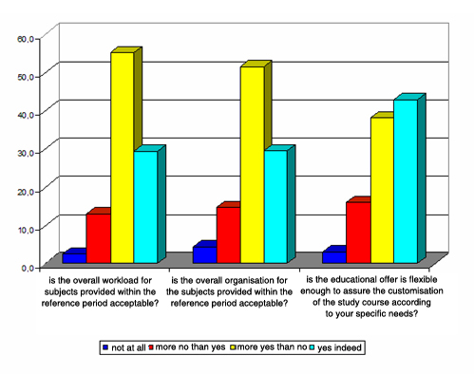

Diagram 1 – Organization of the degree course to which the students were enrolled

Some differences in the answers can be noted if one disaggregates data according to the specific faculty. The perception of the quality of distribution of the study workload is slightly higher for students enrolled in the Law and Economics faculties with percentages of positive assessments equal to 86% and 85%, than for students of the Engineering and Psychology Faculties that ranges between 79% and 83%. The didactic planning and the organisation of the exams have got percentages of positive assessments that are higher among the students of the Psychology and Economics Faculties (87% and 86% respectively), whereas the flexibility of the educational offer for the customisation of the study path is deemed positive, above all of the Law and Economics Faculties (100% and 86% respectively).

The analysis of the data related to the assessment of the organisation of each single subject followed by the student shows a very high level of satisfaction with regard to tutoring effectiveness (93% of positive assessments) and the availability of tutors that got a positive assessment in 90% of the answers. The satisfaction level for the exams organisation is high and can be found in 88% of the answers as well as the online training support activities are available at convenient times (83.7% of the positive answers). From disaggregating the data for each faculty one can deduce that higher incidences of positive assessments generally come from the Psychology, Engineering and Literature Faculties (diagram 2):

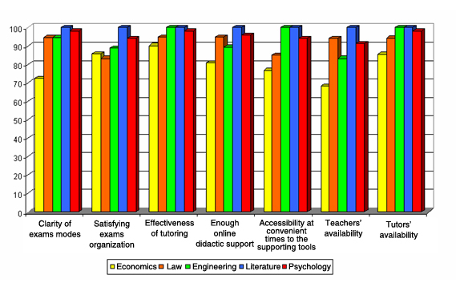

Diagram 2 – Organization of the teaching (values %)

The overall evaluation of the didactic and study activities was analysed through four sets of questions and obtained very high incidences of positive assessments with peaks higher than 90% for certain items.
The students greatly appreciate the clear presentations of course issues both by the professor and by the tutor (96% and 95% respectively of positive assessments) as well as the capacity of professors and tutors to stimulate their interest in the discipline (93% in both cases). The data disaggregated per faculty is showed in diagram 3: the high level of satisfaction expressed in relation to the didactic activities carried on by the professors and tutors of all faculties is evident.

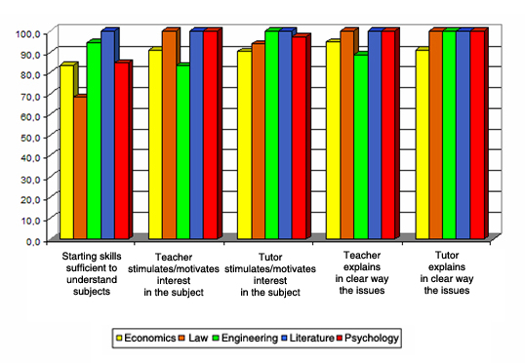

Diagram 3 – Didactic and Study activity, first set of indicators

In addition, students generally appreciate the types of tests made to check their learning progress (90% of positive assessments), they believe that the study workload was appropriate to the ECTS credits assigned for each subject 86%) and that the treated issues were important for their future work career (83%).

The data disaggregated per faculty is illustrated in diagram 4. The perceptions that the checks on learning are adequate and that study is aimed at the comprehension of the subject-matter get a certain uniformity of positive assessments in all faculties. The assessment of the correspondence between study workload and ECTS credits assigned to the subject and the relevance of the treated issues for the future professional career present a degree of variability in the appreciation expressed depending on the faculty the students belong to: as it regards the first item, actually, the positive assessments represent 67% of the answers of the Literature Faculty and 78% of those of Law, 82% of Psychology, 88% of Economics and 89% of Engineering. As to the second item, the Psychology and Literature students attribute more relevance to the issues treated by the disciplines in terms of professional training, whereas in other faculties that perception is weaker: two students of the Law Faculty out of three give to the item rates of 3 or 4 as do 74% of the students of Engineering and 81% of Economics.

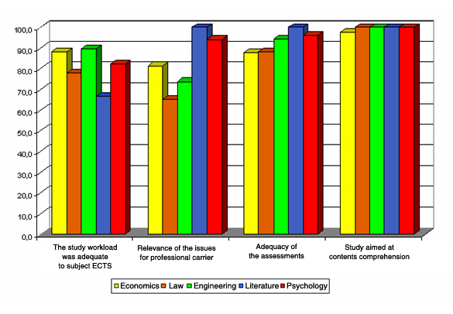

Diagram 4 – Didactic and Study activities, second set of indicators

Besides, from the answers given by the students it appears that the most appreciated didactic tool is exercise, which gets a positive assessment from nearly 97% of the students of the International Telematic University UNINETTUNO.
On the contrary, laboratories and seminars get lower percentage rates of positive assessments and are characterised by a variability that depends on the faculty the students belong to. These last two ones are less used tools in the various subjects since they are still mainly delivered according to experimental modes.

At last, the consultation of the services charter is generally considered useful by more than 71% of the students.

The data disaggregated per faculty are shown in diagram 5. Exercises get a positive assessment in all the questionnaires submitted to the Engineering, Psychology and Literature, Faculties, in 90% of the answers sent by the student of the Law Faculty and in 96% of those from the Economics Faculty.
The consultation of the services charter is considered useful by one students out of three in Engineering and anyhow gets rates of positive assessments around 70% among the students of the other faculties (excepting Literature).

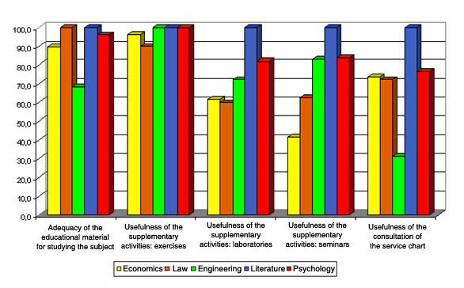

Diagram 5 – Didactic and Study activities, third set of indicators

The analysis of the data shows a great satisfaction expressed by the students as it regards videolessons which are, as expected, the most appreciated support for the students enrolled in UNINETTUNO university degree courses with rates of positive assessments getting around 100% in all Faculties, with the only exception of those enrolled in Engineering.

Online exercises and tutoring are greatly appreciated: the former ones get 94% of positive assessments, whereas the latter ones get 86%. The accessibility to the online administrative secretariat gets a high level of appreciation resulting in 90% of positive assessments. The students also appreciate the possibility of having internship periods and interaction with the labour world for training purposes (84% of positive answers).

Distribution per faculty is shown in diagram 6. Online tutoring is greatly appreciated in at least 81% of the answers. Chats, an indispensable tool for the students to be admitted to the exams are less appreciated by the students enrolled in the Engineering Faculty, among who less than half of them express a negative opinion about these training tools and in Economics where the appreciation is around 62% of the answers. In addition one should remind that chats as well as videoconferences, laboratories and seminars, were during the academic year 2006/2007 in still experimental modes and, as a consequence, students’ appreciation is probably conditioned by the fact that these tools were in a developmental and rather unstable phase.

We have to note a variability of opinions expressed about the usefulness perceived by the students of their interaction with student mates, the learning communities: half of the Economics students who answered to the questionnaire think that this activity is not useful and so does nearly 40% of the Engineering students. On the contrary, this tool is greatly appreciated by the Psychology students.

Finally, the internship periods are deemed useful for learning purposes by the students enrolled in the Psychology and Literature faculties who give positive assessments for 98% and 100% respectively. The rate of positive assessments is, on the contrary, lower for the other students, above all for those of the Law Faculty who think that it is a useful tool in 61% of the answers given.

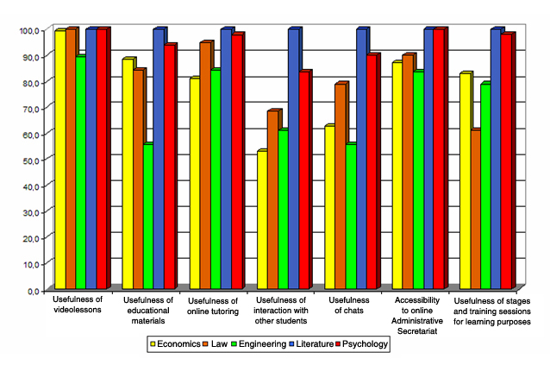

Diagram 20 – Didactic and study Activities, fourth set of indicators

3. Conclusions

The analysis of the data collected in this survey that reflect the opinions of the students indicates a high level of appreciation of didactic materials, such as videolessons and exercises as well as on the effectiveness of online tutoring. These represent the tools that are specific of the Telematic University, and usually are not available in traditional universities. The assessments of other tools, like chats, seminars, and videoconferences were, even if positive, not so convincing. The reason for these results can be found in the inadequacy of the students’ computer equipments. Actually, we noted that the inefficiencies the students complained about, where they could be seen, were solved putting at their disposal suitable equipment at the Technological Poles. UNINETTUNO invested in a number of Technological Poles that up to now are four at the international level and six at the national level.

The tutor’s profile, which turns out to be a very precious tool in the learning path, was highly appreciated for the clarity of the presentation of educational contents and its availability. Also very appreciated were educational contexts, such as exercises and bibliographical references supplementing the lessons.

UNINETTUNO International Telematic University intends to enhance its policy of assuring high quality of the videolessons, exercises and tutoring activities as a whole, that turned out to be perceived as an essential aspect of the high quality of didactics offered.

In short, the survey carried out shows that the students of the International Telematic University UNINETTUNO highly appreciate the educational experience which is characterised by the integration and interaction of multimedia technologies, by the flexibility of the training path and by tools for sharing learning. In short, they appreciates overall innovative and organisational aspects.

