

SURVEY ON THE STUDENTS’ OPINIONS

UNIVERSITY BOARD OF EVALUATION
Academic Year 2006/2007

MARCH 2008

The members of the Board of Evaluation of the International Telematic University UNINETTUNO are:
Dr. Daniela Salmini (lawyer) – President
Prof. Paolo Bastia
Prof. Joost Lowyck
Prof. Derrick De Kerckhove
Dr. Piet Henderikx
Prof. Jacques Perriault
Dr. Natalia Paganelli

The functions of the Back Office of the Board of Evaluation are played by the University Statistics Office, of which Dr. Antonella Mancini is member.

Table of contents

Introduction | 4
1. The questionnaire and its administration to the students | 6
2. The students of the International Telematic University UNINETTUNO | 6
3. A survey on the students’ opinions: results | 13
3.1 Organization of the course of study to which the students were enrolled | 14
3.2 The Organization of the teaching followed and still in progress | 18
3.3 Didactic and study activities | 20
4. Conclusions | 24
Annex 1 Minimum set of questions with integrations | 25
Annex 2 The questionnaire | 29
Introduction

The law 370/99 provided that the Universities’ Board of Evaluations have to make a survey of the opinions of the students attending their courses.
The “students attending the courses” of the International Telematic University UNINETTUNO are to be taken among the students who were admitted to the final exam of each course.
Actually, the Ministerial Decree of April the 17th 2003, which putting into effect art. 26 of the 2003 financial bill established the criteria for the establishment of the Telematic Universities, makes the possibility to take the finale exams of each course conditional on the completion of all the prescribed educational activities, which are documented by the student tracing.
All the students of the International Telematic University UNINETTUNO are to be considered as students attending each course once they have completed all the educational activities that envisaged by it and are documented according to the peculiar modes defined by the above-mentioned Inter-ministerial Decree. Accordingly, the survey on the opinions of the students attending the courses has to be carried out on the students who turn out to have participated in all the educational activities prescribed by that course.

In 2008 the International Telematic University UNINETTUNO started its first survey on the opinions of the attending students, as required by the law 370/99. It is to be reminded that the UNINETTUNO University was established by the D.M (Ministerial Decree) of the 15th April 2005 and that it has started its educational activity according to experimental modes in the academic year 2005/2006; therefore, for the academic year 2005/2006 no survey was carried on, as required by the Law 370/99, since there was no actual starting of the educational activity.

Starting from academic year 2006/2007 the educational activity starter and was supported by educational tools that were, be then, consolidated further to the experience of Consorzio NETTUNO; these include video lessons, online practice work and tutoring and other interesting and innovative tools such as chat-rooms, laboratories and videoconferencing.

During the academic year 2006/2007 the following three-year degrees were delivered:

Economics Faculty Economics and business management (class 17)
Law Faculty Legal Expert in Development and Internationalisation of Enterprises (class 2)
Engineering Faculty Civil Engineering (class 8)
Management Engineering (class 10)
Information and communication technologies engineering (class 9)
Literature Faculty Cultural assets operator (class 13)
Psychology Faculty Psychosocial disciplines (class 34).

The survey outcomes are included into the present document.
The questionnaire proposed by the University Board of Evaluation was administered via computer to the students who in the academic year 2006/2007 turned out to be enrolled in these degree courses and who took part in the didactics as stated by tracing.

It should be emphasised that the students enrolled in the International Telematic University UNINETTUNO are paying students. Actually, since Telematic University cannot benefit from any state fund, the rule that applies of all the other universities, both state and non state one, and that is to say to exempt students from paying fees and enrolment contributions or reduce the sums depending on income, in our case does not applies. Obviously, this represents a substantial disincentive to enrol in a Telematic University rather than to a traditional University, in particular for working students; enrolment fees that were fixed to € 2,000 yearly represent a higher amount if compared to that required on average by traditional universities, especially by the state ones.
It should be highlighted that the International Telematic University UNINETTUNO established enrolment facilitated modes for disabled students, whose enrolment fee was fixed at € 25 yearly.

In preparing the questionnaire, the Board of Evaluation took into account the indications given by the National Committee for the Evaluation of the University System in doc. 9/02, in which the minimum set of questions to be asked to the students was described, taking this minimum set as basic questionnaire and including the following integrations that were aimed at taking into account the educational modes that are specific of the Telematic University:
- Internet-based delivery modes;
- Tutors’ activity
- Educational supporting tools.
In addition, new questions were included that were aimed at detecting the distance education specific aspects. All the integrations are marked in red on the annexed form (annex 1).

The questionnaire is structured upon 4 sections. The first general one collects socio- personal data on the students; the second one makes a survey on the opinions concerning the university degree course in which the student is enrolled; the third one on the organisation of the subject attended and the fourth one on the educational and study activities.

The students were asked to fill in the questionnaire and send it back via computer.
The questionnaire was presented to the students with a letter from the President of the Board of Evaluation that was sent them by the tutors of the Faculties of the International Telematic University UNINETTUNO, who cooperated with the Board of Evaluation.

1. The Questionnaire and its Administration to the Students

The students who participated in the survey were enrolled to the three-year degree course in academic year 2006/2007. In this year the students were 559. Since, as said above, the all the enrolled students are to be considered as attending students, we made an exhaustive type of survey, sending the questionnaire to all the students that were enrolled to the supplied degree courses through their respective tutors. The tutors got in touch with the enrolled students and sent them the letter of the President of the Board of Evaluation illustrating the questionnaire.
The administration of the questionnaire was done via computer through a form structured in four sections:
- The first one of general character, concerning age, place of residence, study title and job;
- The second one concerning the organisation of the study course in which the student was
enrolled;
- The third one concerning the satisfaction level as it regarded the attended course;
- The fourth one related to the educational and study activities that were carried on during the course.
The questionnaire (Annex 2) envisaged the fixing of an evaluation to each question according to a score range from a minimum of 1, corresponding to a “not at all” evaluation, to a maximum of 4, corresponding to “yes indeed”, including two intermediate evaluations corresponding to “more no that yes” and 3 corresponding to “more yes than no”.
The questionnaires received were 233 on the whole. Here below you shall find their results.

2. The Students of the International Telematic University UNINETTUNO

As said above, the questionnaire was administered to all students who in academic year 2006/2007 were enrolled to the three-year degree courses. We thought we had to include a short survey of the data on the students of that academic year that could be useful to get an overall picture of the main characteristics of those who decided to enrol to the International Telematic University UNINETTUNO.

The students enrolled in academic year 2006/2007, regrouped according to the various Faculties, were 559, as shown in table 1 below.

Tab. 1 – students enrolled per degree course – academic year 2006/2007

Degree course | Enrolled students | % Value
Economics | 315 | 56.3
Economics and business management
Law | 44 | 7.9
Legal Expert in Development and Internationalisation of Enterprises
Engineering | 96 | 17.2
Civil Engineering | 11
Management Engineering | 9
Information and communication technologies engineering | 76
Literature | 9 | 1.6
Cultural Assets Operator
Psychology | 95 | 17.0
Psychosocial Disciplines
Total | 559
The distribution according to gender of the students enrolled shows a higher presence of male students: 356 males against 203 females, corresponding respectively to 63.7% and to 36.3%. The higher male presence is confirmed in the Engineering, Economics and Law Faculties (diagram 1).

Diagram 1 – distribution of the enrolled students per Faculty and Gender – academic year 2006/2007
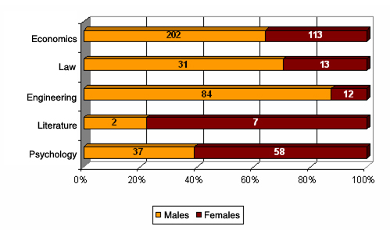

The students’ profile according to age highlights a fair presence of over-fifty-year-old enrolled students, nearly 53% of the total amount; the over-fifty-year-old by themselves represent 13% of the students (diagram 2). 6% of the enrolled students is not older than 19, whereas 18% is between 20 and 29 year-old. These data confirm the hypothesis that those who chose a distance degree are mainly people already in their working age, who, thanks to the learning method proposed by the Telematic University, can reconcile professional and family engagements with the study ones.

Diagram 2 – Distribution of the enrolled students per age classes – academic year 2006/2007
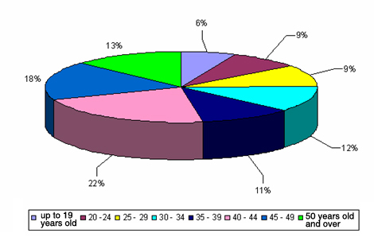

Distribution according to the students’ age classes was regrouped per each Faculty (diagrams 3-7).
The Economics Faculty confirms its more mature composition, which is characterised by 63% of enrolments by over-forty-year-old people. The amount of younger students is fairly low: only 1% is not older than 19, whereas 19% is between 20 and 29 years old.

Diagram 3 – Enrolled in the Economics Faculty per age classes – academic year 2006/2007
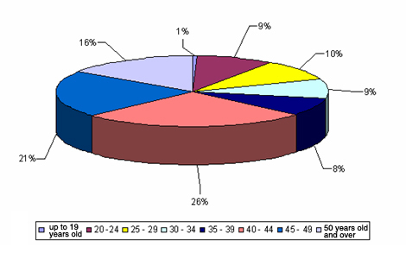

The Law Faculty registered 36% of its enrolments among over-forty-year-old people, whereas the modal class, that is to say the most frequent one, is that comprises between 35 and 39 years old, with 23% of enrolled students.

Diagram 4 – Enrolled in the Law Faculty per age classes – academic year 2006/2007
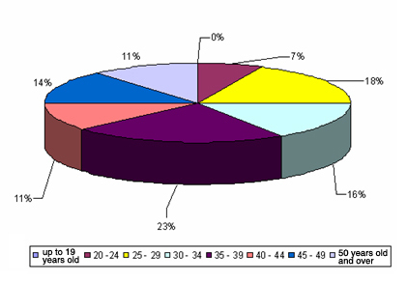

35% of the students enrolled in the Engineering Faculty is not older than 19. This data is conditioned by the enrolment of a group of very young Egyptian students who, through an agreement concluded with the Helwan University, started a study path with the UTIU. Net of these enrolments, the modal age class is 30 – 34 years old, with approximately 22% of the students.

Diagram 5 – Enrolled in the Engineering Faculty per age classes – academic year 2006/2007

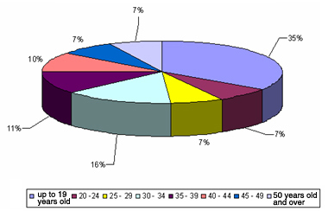

The Literature Faculty is the one that registered a lower number of enrolments, only 9, two of them with an age comprised between 20 and 24 years old and other seven of 30 years old and beyond.

Diagram 6 – Enrolled in the Literature Faculty according to age classes – academic year 2006/2007

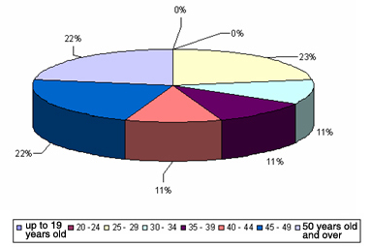

The Psychology Faculty has as modal class the “40 - 44 years old” class, with 22% of enrolments. The younger age classes are less frequent: only 7% of the students is over 24 years old.

Diagram 7 – Enrolled to the Psychology Faculty per age classes - academic year 2006/2007

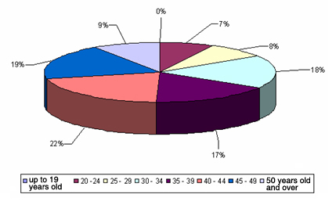

The distribution of the enrolled students according to region of residence is shown in diagram 8. 28.4% of the students of academic year 2006/2007 lived in Sicily, 14.3% in Latium, 10.9% in Veneto and 9,1% in Emilia Romagna. 7,3% lived abroad (41 students). On the whole they were Egyptian students (35 altogether) who accepted the agreement with Helwan University.

Diagram 8 – Enrolled students per region of residence – academic year 2006/2007

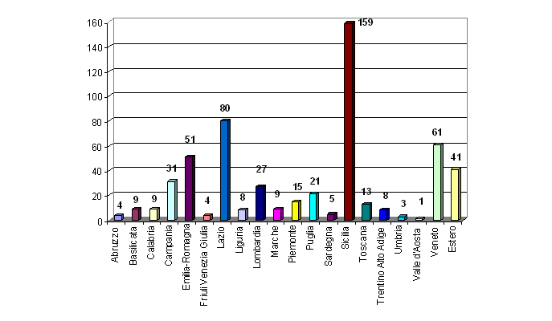

In table 2 are shown the Faculties’ students according of region of residence. The students come from all over Italy: as it regards the Economics Faculty, the students’ higher rate comes from Sicily, from Veneto and from Emilia Romagna; whereas, from Latium come most of the students enrolled in the Law Faculty, Engineering Faculty (excepting the Egyptian students) and of the Psychology Faculty.

Table 2 – Enrolments per Faculty and region of residence – academic year 2006/2007

Region of residence | Economics | Law | Engineering | Literature | Psychology
Abruzzo |  | 1 | 1 | 1 | 1
Basilicata | 5 |  |  | 1 | 3
Calabria | 2 | 1 | 2 |  | 4
Campania | 15 | 4 | 6 |  | 6
Emilia-Romagna | 39 | 3 | 3 | 1 | 5
Friuli Venezia Giulia | 3 | 1
Lazio | 14 | 13 | 22 | 1 | 30
Liguria | 3 |  | 1 | 1 | 3
Lombardia | 7 | 3 | 5 | 1 | 11
Marche | 7 | 1 |  |  | 1
Piemonte | 4 | 2 | 4 |  | 5
Puglia | 3 | 3 | 4 |  | 11
Sardegna | 3 | 1 | 1
Sicilia | 153 | 2 | 3 |  | 1
Toscana | 2 | 3 | 3 |  | 5
Trentino Alto Adige | 5 |  |  |  | 3
Umbria |  | 1 |  |  | 2
Valle d'Aosta |  |  |  |  | 1
Veneto | 49 | 4 | 4 | 2 | 2
Abroad | 1 | 1 | 37 | 1 | 1
Total | 315 | 44 | 96 | 9 | 95

From the data asked to the students upon enrolment it was possible to re-create the profile of the students enrolled according to the type of diploma they got. On the whole over half of the students has a school-leaving diploma in technical disciplines (52%), 13% has a scientific diploma in sciences, 9% has a diploma in vocational training sectors and 8% ha a school-leaving diploma in humanities. Nearly 7% has a foreign study title.

Diagram 9 – School leaving diploma of the enrolled students - academic year 2006/2007
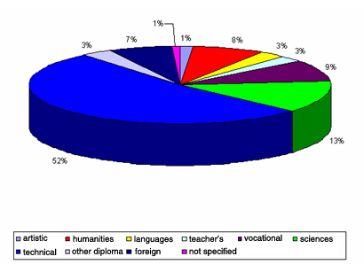

The data related to the school-leaving diploma, structured according to Faculty, is shown in diagram 10. Excepting the Literature Faculty, with its own 9 enrolled students distributed among the different diploma in an homogenous way and of the Engineering Faculty, characterised by the presence of Egyptian students and therefore corresponding to the number of foreign study titles, in the other Faculties it is evident the strong incidence of the students having a diploma in technical subjects.
Among the students enrolled in the Economics Faculty this diploma is held by approximately 66% of the students, whereas the diploma in sciences was obtained by 11% of the students enrolled. In the Law Faculty 48% of the students has got a diploma in technical disciplines and 14% has got a diploma in humanities.
As already highlighted, the Engineering Faculty can count among its enrolled students 35 Egyptian students. As a result, the profile according to type of diploma is characterised by a strong presence of foreign titles. 31% has got a diploma in technical disciplines and 18% in sciences. The Literature Faculty, since it has few enrolments distributed across the various modes, has no predominant typology. 33% of the students enrolled in the Psychology Faculty got a diploma in technical disciplines, 18% in sciences and 13% in humanities.

Diagram 10 – School leaving diploma of the enrolled students per Faculty - academic year 2006/2007
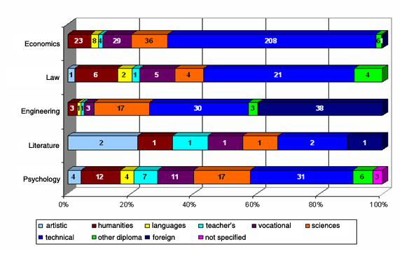

.

3. The Survey on the students’ opinions: results

The questionnaire was administered in electronic format to the students who in the academic year 2006/2007 had enrolled on degree courses offered by UTIU and who followed the teaching courses provided.
Concerning the replies reaching us and which, one must remember, express the students’ judgments on questions relative to the degree course and the teaching according to a value scale from 1 to 4, a descriptive analysis was conducted: calculated there are the absolute and relative numbers and, where it was necessary to provide clarity of presentation to a synthesis, also considered was the percentage incidence of the positive replies out of the total of replies provided, according to the scale of judgment.

233 questionnaires were received, 59% of which were compiled by students enrolled on the Faculty of Economics, 23% by students enrolled in the Faculty of Psychology, 9% by Law students, 8% by Engineering students and 1% by students of Literature (diagram 11)

Diagram 11 – questionnaires received per Faculty
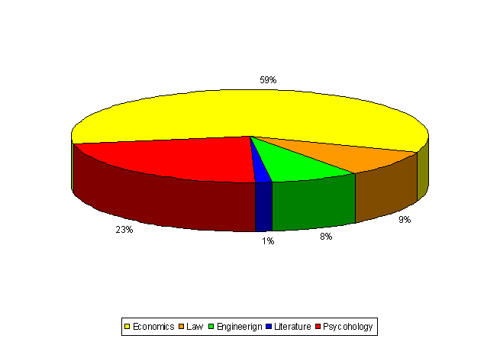
72% of questionnaires received refer to students who declare that they are able to study at most only 3 hours a day, while 28% declare they have more time available to dedicate to study. 55% of the questionnaires indicate a working activity, which takes up at least 8 hours a day, while
about 33% refers to students who work from 5 to 7 hours a day.
It is deduced that the UTIU students are mainly fulltime workers who have only limited time available to devote to studying.

3.1 organization of the course of study to which the students were enrolled

The Organization section of the course of study to which the students were enrolled is composed of three questions asking them to express a judgment via four levels of satisfaction, equal to 1 (not at all), 2 (more no than yes), 3 (more yes than no) and 4 (yes indeed). The questions regard the evaluation of the overall teaching load, of the organization of the didactic planning and exams in the period of reference and of the flexibility of the training offered.

Overall the judgments on the three questions posed in the section are positive: the overall study load of the teachings officially provided for in the period of reference is deemed acceptable with a score equal to 3 in 55% of questionnaires and equal to 4 in 29%; the organization overall (didactic planning and exams) of the teaching officially provided for in the period of reference is deemed acceptable with a score equal to 3 in 51% of the questionnaires and with a score equal to 4 in 29%; the training offer is deemed flexible enough to guarantee the customization of the course of study according to the student’s specific needs with a score equal to 3 in 38% of the questionnaires and with a score equal to 4 in 43%.

Diagram 12 – Organization of the degree course to which the students were enrolled
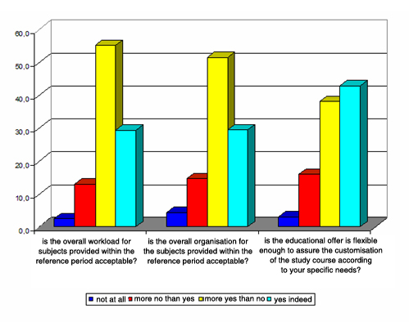

The disaggregated data per Faculty is shown in the following graphics:

The perception that the overall study load in the didactic period is acceptable is strongest, in percentage terms, in the Faculty of Law (72.7% of the replies equal to 3 and 13.6% equal to 4) and of Economics (53.7% of the replies equal to 3 and 31.6% equal to 4). For the Faculty of Literature the replies are few (3 questionnaires in all) and carry the same result, equal to 4. 63.2% and 15.8% of students of Engineering who replied to questionnaires assigned to the question a score equal respectively to 3 and to 4, while the percentages relating to students of Psychology are equal to 51.9% and 30.8%.

Diagram 13 – Is the overall study load of teaching officially fixed in the period of reference acceptable?
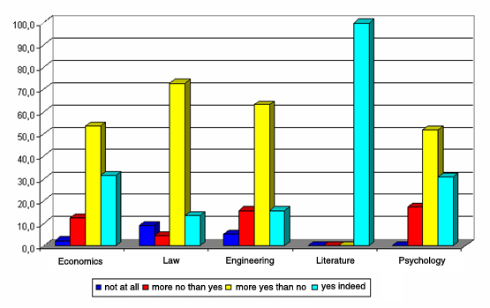
The organization of didactic planning and the exams is perceived as acceptable in a most evident way in the Faculty of Psychology and of Economics, where in the former the score of 3 was assigned in 58.1% of cases and 4 in 27.9%. It needs to be noted that in the Faculty of Engineering – due to start-up problems which were experienced and then completely overcome in the following academic year – a negative judgment was assigned overall concerning the organization of didactic planning and of exams, around 78% of replies having a score equal a 1 or 2. For the Faculty of Literature the replies are few (3 questionnaires in all) and have the same score, equal to 4. 50% of students of Law gave the item a score equal to 3 and 27.3% gave a score equal to 4.

Diagram 14 – Is overall organization (didactic planning and the exams) of the teaching officially fixed in the period of reference acceptable?
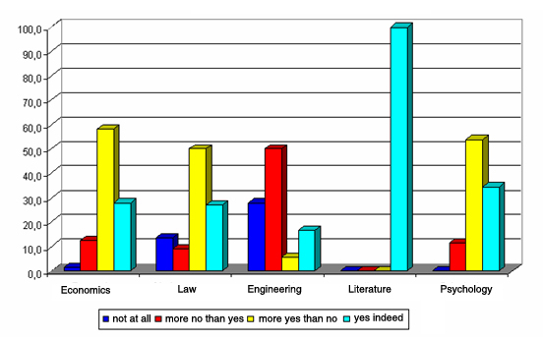
The training offer is judged to be flexible above all by the students of the Faculty of Law and of Economics. The former assigned only positive judgments, precisely 59.1% with a score equal to 3 and 40.9% with a score equal to 4; the latter assigned to 38.2% of the replies a score equal to 3 and to 47.8% a score equal to 4.
The students of the Faculty of Psychology produced in 38.5% of the cases a score of 3 and in 34.6% a score of 4. The few questionnaires coming from the Faculty of Letters all expressed a positive judgment.
It needs to be noted that 61% of those enrolled in the Faculty of Engineering who replied to the questionnaires assigned a negative judgment to the flexibility of the training offer, in fact 33.3% valued it with a score of 2 and 27.8% with a score of 1. Such a negative piece of data is also due to the start-up problems in the Faculty of Engineering, as mentioned above and then overcome in the following academic year.

Diagram 15 – Is the training offer flexible enough to guarantee the customization of the course of study according to your specific needs?
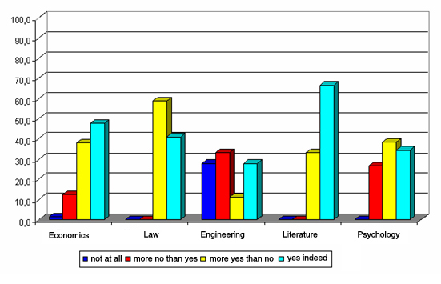

3.2 The Organization of the teaching followed and still in progress

Section 3 of the questionnaire refers in a specific way to the single subject followed by the student and for which the questionnaire was compiled.
The subjects for which the questionnaires were collected are 28 overall, thus divided per Faculty and questionnaires received:

Tab. 3 – Questionnaires received

Faculty | SUBJECT | N. QUESTIONNAIRES
Economics | Accounting and budgeting | 13
Economics | Commercial Law | 24
Economics | Company Economics | 22
Economics | Institutions Private Law | 29
Economics | Institutions Public Law | 16
Economics | Institutions Political Economics | 3
Economics | Foreign Language | 7
Economics | Marketing | 1
Economics | Financial Mathematics | 1
Economics | Planning and control | 1
Economics | Statistics | 19
Economics | Overall total | 136
Law | Political Economics | 8
Law | Philosophy of Law | 10
Law | Foreign Language | 3
Law | Statistics | 1
Law | Overall total | 22
Engineering | Algorithms and advanced planning | 7
Engineering | General Physics 1 | 3
Engineering | General Physics 2 | 3
Engineering | Foreign Language | 5
Engineering | Enterprise Quality and culture | 1
Engineering | Overall total | 19
Letters | Aegean Civilizations | 1
Letters | Show Business disciplines | 1
Letters | History of Greek and Roman Art | 1
Letters | Overall total | 3
Psychology | Biological bases of behaviour | 15
Psychology | Foreign Language | 2
Psychology | Language and communication | 8
Psychology | Perception | 16
Psychology | Psychology of the personality | 12
Psychology | Overall total | 53

The questions concern the evaluation of the exam procedures, of the efficacy of the tutoring, of the sufficiency of the teaching material, and of the accessibility to the teaching materials in relation to the timetable and then of the availability of the teachers and tutors.

As an indicator of the level of satisfaction expressed by the students who answered the questionnaire we considered the incidence of replies “more yes than no” and “yes indeed” (scores of 3 and 4) out of the total of the replies supplied. The data were aggregated by Faculty, not being higher than the number of questionnaires received per each subject taught. The results relating to the items of section 3 are reported in the following graph, divided up by Faculty.

Diagram 16 – Organization of the teaching (values %)
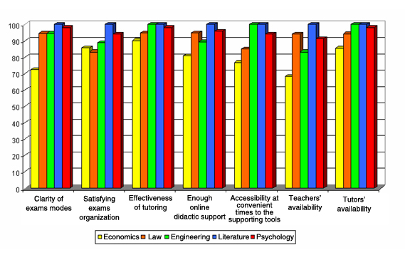

A premise needs to be made when commenting on the data: the satisfaction expressed by the students is high for all the questions posed, with a percentage of positive judgments equal to at least 68%; it can be observed, however, that by and large the replies to the questionnaires coming from Faculty of Economics contain a lower frequency of positive judgments for the various questions posed in section 3, if compared to those coming from the other Faculties; it does involve, though, positive assessments, with percentages equal, as mentioned before, to at least 68% of the total of the replies.
It turned out that particularly satisfying are the assessment of the didactic support online, of the efficacy and availability of the tutors, with scores of over 90%.
For the Faculty of Economics the items with the lowest percentages are the availability of the teachers and the clarity of the exam procedures, these scoring positive judgments of 68% and 72% respectively.

Overall, the questions, which registered the lower satisfaction, are the availability of the teachers (an expected result, in fact, given the students’ interface contact mainly with the tutors), together with organization of the exams and accessibility to didactic support online at convenient hours of the timetable (for example, ‘chat’).

3.3 Didactic and study Activities

The last section of the questionnaire (the fourth) aims to verify the level of satisfaction as regards the didactic and study activities in each discipline.
The data are presented gathering the positive judgments expressed by the students of each Faculty.

The first set of questions in the didactic activity and study section aims to verify to what extent the knowledge already possessed by the students in the form of cultural baggage is useful for understanding the topics treated during teaching, and how the teachers and tutors can best motivate and stimulate interest in the discipline being studied and how clearly they explain the topics taught.
The indicator constructed as a percentage of positive scores out of the total of judgments shown demonstrates all in all a rather high evaluation expressed on all these, although one observes that the lower percentages are registered regarding the sufficiency of preliminary knowledge possessed by the students, with the exception of the Faculties of Engineering and of Letters, with percentage values which range from 68% for the Faculty of Law to 84% for Economics, and 85% for Psychology.
Concerning the capacity of the teacher to stimulate and motivate interest in the discipline, to be noted is the full satisfaction of the students enrolled in the Faculties of Law, Letters and Psychology, to which we can also add the appreciation expressed by 91% of the students of Economics and by 83% of Engineering students.
Also the capacity of the tutor to stimulate interest in the discipline was perceived positively by the students, with scores equal to 3 or 4 in over 90% of the replies.

The topics are explained in a clear manner both by the teacher and by tutor: the students of Engineering were a little less satisfied than the other students as regards the clearness of the teachers’ exposition, but nevertheless reported positive judgments overall, equal to 89% of the cases.

Diagram 17 – Didactic and Study Activity, first set of indicators
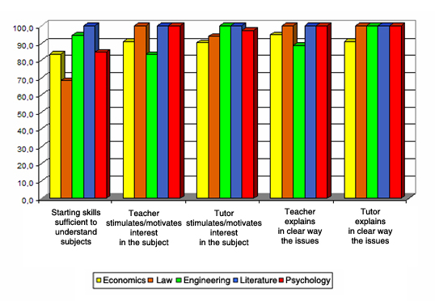

The second set of questions aims to verify the satisfaction level regarding the correspondence of the didactic load to the number of University Credits recognized for the teaching, to the relevance of the themes treated for the professional training, to the adequacy of the checks adopted and to the study aimed at understanding the contents.

While the adequacy of the checks and the study aimed at understanding the contents bear a certain uniformity of positive judgments in each Faculty, as the diagram below shows, regarding the perception that the study load might be proportioned to University Credits assigned to the teaching and to the relevance of the themes treated a different level of satisfaction is observable according to which Faculty the student belongs to. Concerning the first question, positive judgments represent 67% of the replies from students of Literature and 78% from students of Law, 82% of Psychology students, 88% of Economics students and l’89% of Engineering students. Regarding the second question, the students of Psychology and of Literature perceive in greater measure the relevance of the themes treated by the study disciplines for professional training, while in the other Faculties the perception is hazy: two Law students out of three score the item with a 3 or 4, as do 74% of the students of Engineering and 81% of those of Economics.

Diagram 18 – Didactic and Study Activities, second set of indicators
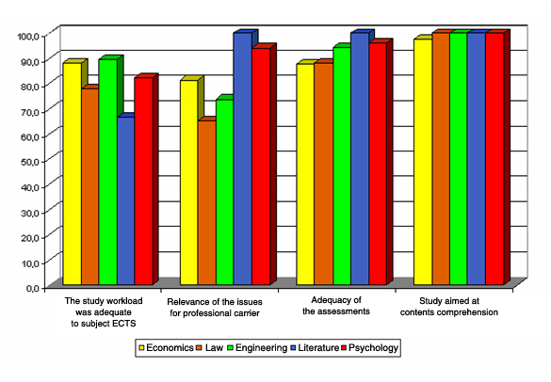
The third set of questions aims to verify the satisfaction as regards didactic materials used in delivering the subject. Overall, one observes that the students of Engineering find the didactic material somewhat lacking for the study of the subject; in fact, one student in three assigned it a negative score; the students of the other Faculties, however, were mostly satisfied in this regard. With satisfaction levels as high as around 90%. The most appreciated tool was definitely the exercises and practice, valued positively by around 90% of the students of Law, by 96% of Economics students and by nearly all the students of the other Faculties.
The laboratories and seminars (tools in fact less used for the various topics taught, being still provided in a mainly experimental way) registered a percentage of highest satisfaction level, above all among students of Economics and Law.
Finally, consultation of the services’ card is not judged to be useful by two out of three students of Engineering, although it does earn a higher percentages of positive judgments in comparison to questions, also among the students of the other Faculty (except for Literature).

Diagram 19 – Didactic and Study Activities, third set of indicators
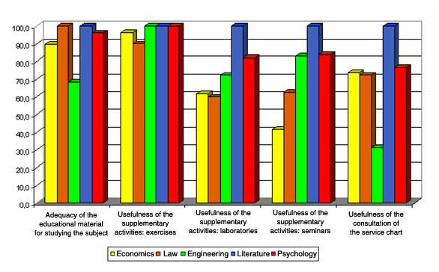

The fourth group of questions of the Didactic Activity and Study section considers the usefulness of the didactic support supplied on line for learning purposes. The video-lessons are, as expected, the students’ most popular support with the percentage of positive judgments proving to be at around 100%, the sole exception being students enrolled in Engineering, these expressing a lower level of satisfaction, but which is still above 80%. Also much appreciated is the online tutoring, which registers positive judgments in at least 81% of the replies. ’Chat’, an indispensable tool for admission to the students’ exams, is less appreciated by those enrolled in the Faculty of Engineering, little less than half the students judging this didactic support negatively, as is also the case with Economics students, where appreciation is at around 62% of the replies. It should also be noted that ‘chat’ as in the videoconferences, the laboratories and seminars, in the academic year, were only available in a still experimental condition.
Another area of consideration is the perception of usefulness provided by the students concerning an interaction with study companions, the learning communities: half the Economics students who answered the questionnaire did not think this activity was useful, likewise around 40% of the students of Engineering. On the other hand, the students of Psychology perceive it as a useful study tool.
The satisfaction level is high for online accessibility to the administrative secretariat, with percentages above 83% of judgments expressed being positive.
Lastly, the ‘stages’ were found useful for learning by students enrolled in Psychology and Literature, with positive judgments at 98% and 100% respectively. Satisfaction was less high for the other students, above all for students of Law whose positive judgments as to usefulness were 61% of the judgments expressed overall.

Diagram 20 – Didactic and study Activities, fourth set of indicators
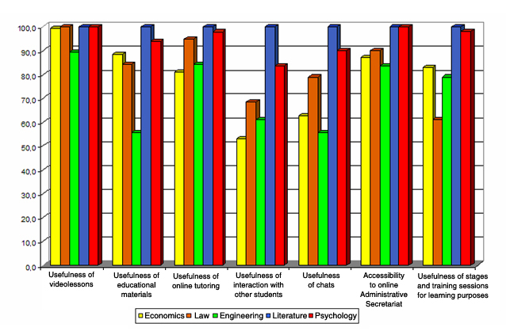

4. Conclusions

The data above give rise to the following considerations:

1. The questionnaire was given to all the 559 students enrolled in academic year 2006/2007, with 233 of them completing a reply;

2. The assessments as regards some of the didactic tools, such as chat, laboratories and seminars and videoconferences, though for the most part positive, were still less favourable than were those regarding video-lessons, exercises and tutoring. The reason is found in the inadequacy which often occurred in the students’ own computer equipment. It was seen that the shortcomings the students complained of were often solved once they were given access to more suitable equipment at the technological Poles. UNINETTUNO has invested in the technological Poles which number so far four at international level and six at national level
Analysis of the data suggests that the technological Poles be strengthened as a development strategy for academic year 2007/2008 and the years ahead.

3. Of considerable significance are the evaluations of the videolessons, exercises and efficacy of online tutoring, these representing the specific tools of the Telematic University and not usually found in traditional Universities. Such instruments were available in academic year 2006/2007 in already consolidated form. The relevant evaluations are decidedly positive, being around 80-90% in all the Faculties.
For academic year 2007/2008 and ahead it will be necessary to continue a policy of quality in the videolessons, exercises and online tutoring, these all having been demonstrated as being perceived by the students as the essential hinge for the high quality of education offered by the International Telematic University UNINETTUNO.

More generally, the student opinion survey carried out on the 2006/2007 intake registers on average a high level of satisfaction with the organization of the degree courses and the didactics, with decidedly high percentages, save some criticisms already shown in the analysis conducted, traceable to problems of didactic activity in its very early stages and which subsequent study was carried out to set them right.

An analysis of the open replies confirms the considerations undertaken relative to the replies to the questions. Particularly striking is the positive evaluation of tutoring activity, especially that carried out on, showing itself capable of responding to requests for clarification and so making a direct meeting with the teacher unnecessary. It is also useful to emphasize, among the students’ suggestions, the request for a larger number of exam sessions with well-defined dates during the delivery of the teaching itself so as to meet the needs of students who have to work, giving them a good margin of time to organize the necessary permission and travel arrangements in order to take the exams.

Annex 1 – Minimum set of questions with integrations

Students’ Opinions on Didactic Activities
Questionnaire
Dear Student,
UNINETTUNO is eager to continuously improve its quality. One of the main tools to gather necessary feedback is the honest answer on a limited set of questions predisposed from the Evaluation Board. Please answer all questions.
UNINETTUNO will take your answers seriously in its process of quality assurance.
Thank you for your collaboration.
We highly appreciate!

General Information

- Age………………………………………….

- Area of Residence…………………………………

- High School Diploma
Specialising in Humanities
Technical
Vocational
Teachers’ training
University degree
Other (pls specify)………………………….

- Have you got a job?
⁯ Yes, full time
⁯ Yes, part time
⁯ No

- If yes, how many hours per day do you spend in studying on average? ……………………..
- If you have a job, how many hours per day do you spend working on average? ……………………………

- University Degree Course in …………………………………..

Organisation of the study course

 | Negative Evaluations |  | Positive Evaluations
Express your own opinion on the following statements | NOT at all | More NOT than YES | More YES than NOT | YES indeed
8. Is the overall workload for subjects officially provided within the reference period (two months, three months, six months, module) acceptable?
9. Is the overall organisation overall programming and exams) for the subjects officially provided within the reference period acceptable?
10. Is the educational offer is flexible enough to assure the customisation of the study course according to specific needs?

Notes ………………………………………………………………………………………
………………………………………………………………………………………
………………………………………………………………………………………
………………………………………………………………………………………

Organisation of the course that you attended or you are attending

- Course……………………………………………….

- Course year ……………………………………………….

 | Negative Evaluations |  | Positive Evaluations
Express your own opinion on the following statements | NOT at all | More NOT than YES | More YES than NOT | YES indeed
13. Were the exams modes clearly established?
14. The way the exams are organized is satisfactory to me?
15. Is tutoring organised in an efficient way?
16. Are online didactic activities and tutoring enough?
17. Are online support didactic activities and tutoring accessible at convenient times?
18. Are the teaching staff (professors) actually available to get explanations and clarifications?
19. Are the teaching staff (tutors) actually available to get explanations and clarifications?

Notes ……………………………………………………………………………………..
……………………………………………………………………………………..
……………………………………………………………………………………..
……………………………………………………………………………………..

Didactic and study activities

 | Negative Evaluations |  | Positive Evaluations
Express your own opinion on the following statements | NOT at all | More NOT than YES | More YES than NOT | YES indeed
20. Was my past knowledge sufficient to understand the treated subjects?
21. Does the professor stimulate / motivate the student’s interest in the subject?
22. Does the tutor stimulate / motivate the student’s interest in the subject?
23. Does the professor present the subjects in a clear way?
24. Does the tutor present the subjects in a clear way?
25. Does the study workload required for this subject correspond to the number of credits allocated?
26. The subject-matter taught in the course is relevant for my future job?
27. I am acknowledged with the specific type of examination that takes place
28. I learned not only to reproduce information but to have insight in the subject-matter as well
29. Is the didactic material (suggested or supplied) appropriate to study the subject?
30. I think the following supplementary didactic activities useful for learning purposes:
- exercises
- laboratories
- seminars
31. I think it useful to consult the service charter, that is available online?
32. Are the web-based aids useful for learning purposes?
33. In particular:
- video lessons
- web-base didactic materials
- on-line tutoring services
- interaction with other students (communities)
- chat-rooms
- on-line exercises
34. Is the administrative secretariat in wholly on-line and is it easily accessible?
35. I think it useful to have a stage and have relations with the business and job world for educational purposes?

Notes ………………………………………………………………………………………
………………………………………………………………………………………
………………………………………………………………………………………
………………………………………………………………………………………
……………………………………………………………………………………

Annex 2 – the questionnaire

Students’ Opinions on Didactic Activities
Questionnaire
Dear Student,
UNINETTUNO is eager to continuously improve its quality. One of the main tools to gather necessary feedback is the honest answer on a limited set of questions predisposed from the Evaluation Board. Please answer all questions.
UNINETTUNO will take your answers seriously in its process of quality assurance.
Thank you for your collaboration.
We highly appreciate!

General Information

- Age………………………………………….

- Area of Residence…………………………………

- High School Diploma
Specialising in Humanities
Technical
Vocational
Teachers’ training
University degree
Other (pls specify)………………………….

- Have you got a job?
⁯ Yes, full time
⁯ Yes, part time
⁯ No

- If yes, how many hours per day do you spend in studying on average? ……………………..
- If you have a job, how many hours per day do you spend working on average? ……………………………

- University Degree Course in …………………………………..

Organisation of the study course

 | Negative Evaluations |  | Positive Evaluations
Express your own opinion on the following statements | NOT at all | More NOT than YES | More YES than NOT | YES indeed
8. Is the overall workload for subjects officially provided within the reference period (two months, three months, six months, module) acceptable?
9. Is the overall organisation overall programming and exams) for the subjects officially provided within the reference period acceptable?
10. Is the educational offer is flexible enough to assure the customisation of the study course according to specific needs?

Notes ………………………………………………………………………………………
………………………………………………………………………………………
………………………………………………………………………………………
………………………………………………………………………………………

Organisation of the course that you attended or you are attending

- Course……………………………………………….

- Course year ……………………………………………….

 | Negative Evaluations |  | Positive Evaluations
Express your own opinion on the following statements | NOT at all | More NOT than YES | More YES than NOT | YES indeed
13. Were the exams modes clearly established?
14. The way the exams are organized is satisfactory to me?
15. Is tutoring organised in an efficient way?
16. Are online didactic activities and tutoring enough?
17. Are online support didactic activities and tutoring accessible at convenient times?
18. Are the teaching staff (professors) actually available to get explanations and clarifications?
19. Are the teaching staff (tutors) actually available to get explanations and clarifications?

Notes ……………………………………………………………………………………..
……………………………………………………………………………………..
……………………………………………………………………………………..
……………………………………………………………………………………..

Didactic and study activities

 | Negative Evaluations |  | Positive Evaluations
Express your own opinion on the following statements | NOT at all | More NOT than YES | More YES than NOT | YES indeed
20. Was my past knowledge sufficient to understand the treated subjects?
21. Does the professor stimulate / motivate the student’s interest in the subject?
22. Does the tutor stimulate / motivate the student’s interest in the subject?
23. Does the professor present the subjects in a clear way?
24. Does the tutor present the subjects in a clear way?
25. Does the study workload required for this subject correspond to the number of credits allocated?
26. The subject-matter taught in the course is relevant for my future job?
27. I am acknowledged with the specific type of examination that takes place
28. I learned not only to reproduce information but to have insight in the subject-matter as well
29. Is the didactic material (suggested or supplied) appropriate to study the subject?
30. I think the following supplementary didactic activities useful for learning purposes:
- exercises
- laboratories
- seminars
31. I think it useful to consult the service charter, that is available online?
32. Are the web-based aids useful for learning purposes?
33. In particular:
- video lessons
- web-base didactic materials
- on-line tutoring services
- interaction with other students (communities)
- chat-rooms
- on-line exercises
34. Is the administrative secretariat in wholly on-line and is it easily accessible?
35. I think it useful to have a stage and have relations with the business and job world for educational purposes?

Notes ………………………………………………………………………………………
………………………………………………………………………………………
………………………………………………………………………………………
………………………………………………………………………………………
……………………………………………………………………………………

